Course Co-Ordinator (Project in Computer Science)
Dept. of Computer Science
Faculty of Natural Sciences
The Open University of Sri Lanka

Friday, July 31, 2026

Dear Student,

Kindly inform you to submit your project proposal to your supervisor and get the approval to complete the registration before 1st of June since Add/Drop period will be on 16th and 17th June 2023.

The finalized student list will be sent to the Dean/FNSC on 10th June and last date for the registration for this subject will be 16th June (Date of Add/Drop).

Kindly advise you to strictly follow the deadlines to avoid the unnecessary delays.

Thank you.

CSU5320: Project in Computer Science

It is a pleasure to inform you that the above course will be offered in the academic year 2021/2022.

This course consists with 03 credits and the project work will be subject(s) specific. That is, if you are interested in a particular subject(s) in Level 3, 4 and/or Level 5 you can do a project based on that preferred area. It will be supervised by your academic staff member(s) in the Department of Computer Science who is an expert in that area. This work need not to be a research project.

The criteria to follow CSU5320 (Project in Computer Science) is as follows:

- Pass in ALL Level 03 & 04 Computer Science courses.

S1 Structure: CSU4300, CSU4301, CSU4302, CSU4303
NS1 Structure: CPU2140/CSU4302, CPU2241/CSU4315, CPU2242/CSU4616

- Eligibility or Concurrent Registration for CSU5300.
- Eligibility or Concurrent Registration for Level 05 courses with relevant to the project.
(Course selection should be done in consultation with the prospective supervisor(s))

Note: Please refer Guidebook 2023/2024 BSc Degree Programme - S1 Structure.

It should also be noted that only a limited number of students will be registered having evaluated the proposals submitted. The selection of students will be totally depend on the decision of the department of Computer Science.

If you are interested to follow this course, you are required to submit your project proposal to the office of the Head/Computer Science (3rd Floor: Science & Technology Building) as soon as possible in order to facilitate the re-registration process. You must follow the guidelines under the attached “Project Proposal Guidelines”. You can meet or email your field expert academic in the Department of Computer Science and get more details about this.

For any clarification pl. call the below mention hand phone number.

Thank You.

Course Co-Ordinator
(Dr. Renuka, Tel : 0718258172, Email: mjper@ou.ac.lk)
Dept. of Computer Science.

Project Proposal Guidelines
The aim of doing, a project is applying appropriate principles to solve a problem. It is important to evaluate whether the problem you are addressing is sufficient for a good project. In order to demonstrate about the problem and the proposing solution, you must write a Project Proposal which may include a maximum of 03 pages. The project proposal should cover the following aspects.
Title:
Every Project must have a title. A project title is expected to be as specific as possible. Note that during the project work, the project title can be changed slightly. Such a change should be done only in consultation with your supervisor(s).

Introduction:
Write a short description about the entire project proposal. This can be done by writing one or two sentences about each section of the report.

Aim:
There should be one and only one specific aim for the project. The title of the project should have a clear connection to the aim.

Objectives:
During your attempt to reach the aim, there may be several intermediate achievements or targets. These are called as objectives. Note that, objectives of a project are very important. There are no projects without objectives. The achievement of objectives is the success of a project.

Background and Motivation:
Since projects are generally difficult to proceed with, it has been customary to see whether the student has a strong motivation towards the project. After reading this section the reader should be able to clearly identify the facts that motivated the student to select the proposed topic and it should be indicated that the selected problem has not been addressed so far.

Problem:
Once you describe the background and your motivation, the next is to brief the problem you are addressing.

Methodology adapted: (to solve the problem):
In this section you should write the methodology or technique that you are going to use for solving the problem. You may also explain why this approach is better than other approaches.

Proposed Approach:
In this section, it is expected to provide a description of inputs for your system, users of the system, intended output and the essential functionalities of the system. You may use any form of diagram(s) (formal/informal) for this purpose.

Resource requirements:
List the hardware, software, and other requirements to carry out your project work. Describe how you plan to gather those resources.

Time Schedule:
It is better to provide a rough outline of how you plan to devote time for various activities of the project. It is better to provide a Gannt Chart.

A General Format for a Project Proposal

Cover Page
Font Type: Times New Roman

Project title

Course Name

Course Code

Name of the department

Your name
Registration number
Telephone No
Email
Submission Date

20pt

18pt

16pt
14pt

12pt

Formatting Guidelines
- Font Type: Times New Roman
- Font sizes: Headings = 14pt, Subheadings = 13pt, Paragraph= 12pt
- Margins: Left, Right, Bottom, top = 1.0”
- Page Numbering: Example. Page no/no of Pages (2/3)
- Figures, graphs and tables naming
Example. Figure 1: Gantt Chart
Table 1: Table One
Graph 1: Graph One
- Line Spacing: 1.5

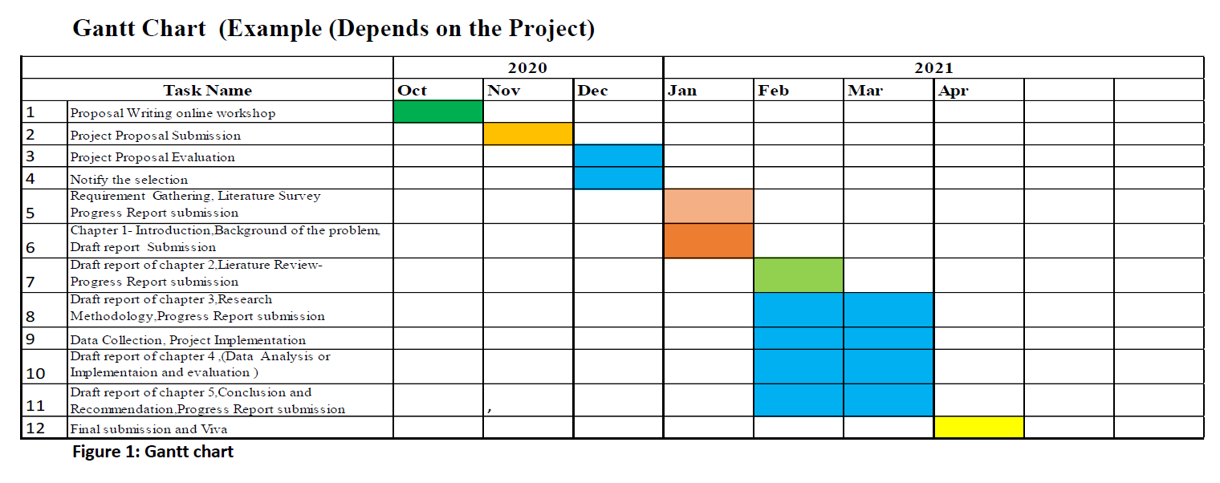
As a example you can follow up a Gantt chart as follows to mange your Time to reach up to the goals..

